Computer Programming Using Kivy - OpenGL 2 - Multiple Objects
GOAL: use the Glops 3D engine to rotate more than one mesh in a 3D scene.

(You must first have a completed and working opengl1.py)
Update the 3D engine:
- Go to your home drive (File Explorer, Computer, T:\username or H:)
- Go to your opengl folder, then double-click update-kivyglops

Implement the update_glops method to make a program where you can rotate the selected glop when using arrow keys:
- Open Geany
- File, Open, your home drive (such as T:\username or H:), opengl, opengl1.py
- File, Save As, go to your opengl folder, then name this file opengl2.py
- Implement the update_glops method to your MainScene class:

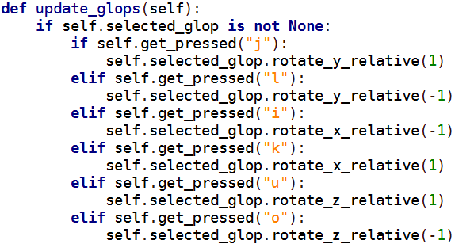

Try your program:
- Execute
- Use the letter keys j, k, l, u, i, or o as directional keys to rotate selected object
- Press Tab to change which object is selected, then try rotating again
